

Practices for Secure Software Report

Table of Contents
Document Revision History 3
Client 3
Instructions 3
Developer 4
1. Algorithm Cipher 4
2. Certificate Generation 4
3. Deploy Cipher 4
4. Secure Communications 4
5. Secondary Testing 4
6. Functional Testing 4
7. Summary 4
8. Industry Standard Best Practices 4

Document Revision History

Version | Date | Author | Comments
1.0 | 10/20/2026 | Michael Williams

Client



Instructions

Submit this completed practices for secure software report. Replace the bracketed text with the relevant information. You must document your process for writing secure communications and refactoring code that complies with software security testing protocols.

- Respond to the steps outlined below and include your findings.
- Respond using your own words. You may also choose to include images or supporting materials. If you include them, make certain to insert them in all the relevant locations in the document.
- Refer to the Project Two Guidelines and Rubric for more detailed instructions about each section of the template.

Developer
Michael Williams

Algorithm Cipher

To secure Artemis Financial’s client data and financial records, I recommend deploying SHA-256 (Secure Hash Algorithm 256-bit) for data integrity verification, paired with TLS 1.3 / HTTPS (AES-256 and RSA 2048-bit) for transport encryption.
- Overview: SHA-256 is a cryptographic hash function that converts an arbitrary input string into a fixed 256-bit (64-character hexadecimal) checksum. It is one-way (irreversible), deterministic, and collision-resistant. Even altering a single character in the source data generates a completely different hash, enabling immediate detection of data tampering.
- Bit Levels & Security: With a 256-bit output, SHA-256 provides 128 bits of security against collision attacks, requiring approximately $2^{128}$ operations to break. This makes brute-force attacks computationally impossible with modern hardware and guarantees dependable file verification for financial transactions.
- Random Numbers & Key Architecture (Symmetric vs. Asymmetric):
  - Asymmetric Encryption (RSA 2048-bit): Uses public/private key pairs within digital certificates to authenticate server identity and securely negotiate session keys.
  - Symmetric Encryption (AES-256): Uses a single shared session key for fast, bulk payload encryption during active connections.
  - Random Numbers: All session keys and cryptographic nonces rely on Cryptographically Secure Pseudo-Random Number Generators (CSPRNG, like Java's SecureRandom) to ensure session tokens cannot be guessed.
- History & Current State: Legacy algorithms like MD5 (128-bit) and SHA-1 (160-bit) have suffered practical collision attacks and are deprecated by NIST. SHA-256 is a member of the NIST-approved SHA-2 family and is the current industry standard across banking, cloud infrastructure, and enterprise communications.

Certificate Generation
Insert a screenshot below of the CER file.
A self-signed X.509 digital certificate was generated using the Java Keytool utility in PKCS12 format and exported as a .cer file.

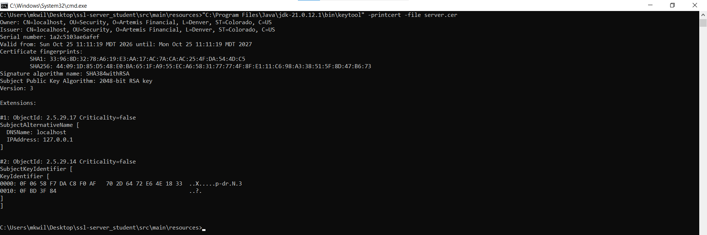

Deploy Cipher
Insert a screenshot below of the checksum verification.
The SHA-256 algorithm was implemented in Java via java.security.MessageDigest and exposed through the /hash REST endpoint to generate a deterministic checksum for payload verification.

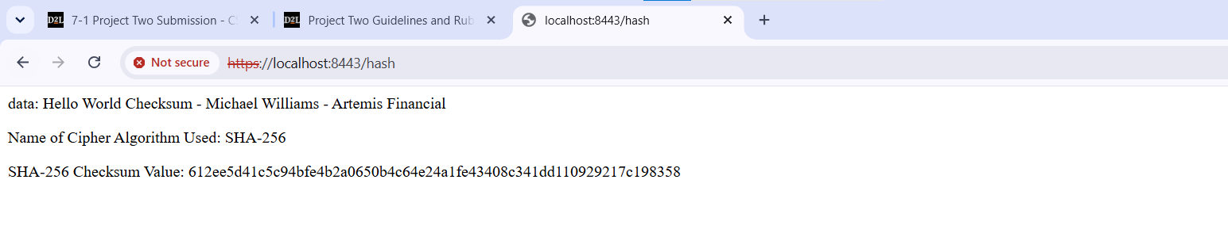

Secure Communications
Insert a screenshot below of the web browser that shows a secure webpage.
The application was refactored from unencrypted HTTP (port 8080) to HTTPS (port 8443) by configuring application.properties with the PKCS12 keystore. Navigating to https://localhost:8443/hash confirms that secure, encrypted TLS communications are operational.

Secondary Testing
Insert screenshots below of the refactored code executed without errors and the dependency-check report.
Secondary static security testing was conducted using the OWASP Dependency-Check Maven plugin. The refactored code compiled cleanly with zero errors (BUILD SUCCESS), and the scan verified that no vulnerable third-party libraries were introduced.

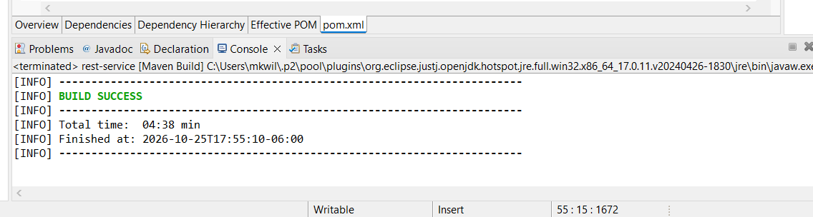

Functional Testing
Insert a screenshot below of the refactored code executed without errors.
A manual code review and functional verification were completed on SslServerApplication.java. The refactored code defensively enforces StandardCharsets.UTF_8 encoding, handles NoSuchAlgorithmException cleanly, and executes without runtime errors, memory leaks, or uncaught exceptions.

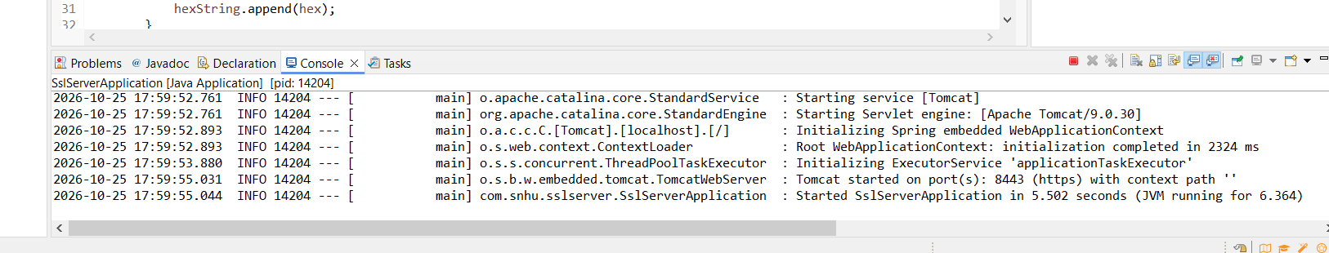

Summary

- Areas of Security Addressed (Vulnerability Assessment Process Flow):
- Communications Security: Migrated the service from plaintext HTTP to HTTPS/TLS on port 8443, eliminating Man-in-the-Middle (MitM) eavesdropping and packet sniffing.
- Data Integrity: Deployed SHA-256 hashing so Artemis Financial can cryptographically verify that client records have not been altered in transit.
- Dependency & Component Hygiene: Added OWASP Dependency-Check to prevent known vulnerable dependencies from reaching production.
- Adding Layers of Security (Defense in Depth): We applied security across multiple levels: transport-layer encryption (TLS/PKCS12), application-level cryptographic verification (SHA-256), defensive coding (deterministic UTF-8 encoding and checked exceptions), and supply-chain vulnerability scanning.

Industry Standard Best Practices

- Maintaining Existing Security: We adhered to established OWASP and NIST guidelines: using approved cryptographic standards (SHA-256, RSA 2048), enforcing the principle of least privilege on network ports, sanitizing inputs, and implementing secure error handling so internal server paths are never leaked to clients.
- Business Value for Artemis Financial: For a financial advisory firm, safeguarding customer portfolios and personal identifiable information (PII) is essential to business viability. Secure coding protects against regulatory penalties and legal liabilities, prevents costly data breaches, and preserves customer trust. Automated security testing during development significantly reduces remediation costs compared to fixing bugs post-deployment.

